**Android task monitoring**

**Team:**

كلارا باسم فكرى قلته (Team Leader)

ماريا ايمن ابراهيم غبريال

كيرلس جورج رفعت جاد

مارى جرجس حنا جرجس

ماريان اشرف بشرى حبيب

**Project Summary:**

* We are so busy in our daily lives right now that it becomes impossible to keep track of our daily events, meetings and appointments.
* To address this issue, our project focus on developing a daily, weekly and annual task alerting system for android devices that can alert users of the tasks/appointments that are scheduled for each day in a year.
* Our project provides some features to our users such as:
* Simplify the tracking and monitoring of day-to-day activities of the busy modern life.
* Users can use this application to set goals and achieve them, thereby increasing productivity and simplifying their lives.
* The developed project is a tasks reminder app, with AI-powered Chatbot that will make user enjoy productivity.
* Users can give preferences to each task.
* Secured accounts.
* No need to utilize mind in remembering routine tasks.
* You will have the ability to listen to music.
* Study stream.
* Pomodoro technique.
* The app’s cost will be 50$ per download so the following will be the tangible value to the company:
* Total benefits in sales from downloading is (22,500,000$).
* Total benefits in sales from advertisements is (8640$)
* Total Net benefits = 21,213,792$
* NPV = 14,988,213$ (NPV > 0 so our project is acceptable)
* Our system is **medium complex**.
* Length: our system will take as maximum **one year**.
* Number of Developers: We need:
* 7 developers: five for android :(three for java, two for Kotlin) and two for graphic designer.
* 1 database man(sign in & sign up)
* 2 sales men
* Special Issues or Constraints:
* Illegal in some Countries for political reasons.
* Application only compatible with android devices.
* Few users may find it difficult to deal with application.

|  |
| --- |
| System Request – Android Task Monitoring |
| Project Sponsor: Kirollos George Refaat, Marian Ashraf Boshra, Mary Girgis Hanna, Clara Bassem Fekry, Maria Ayman Ibrahim. |
| Business need: We are so busy in our daily lives right now that it becomes impossible to keep track of our daily events, meetings, and appointments.  To address this issue, this project focuses on developing a Weekly Task Alerting System for Android devices that can alert users of the tasks/appointments that are scheduled for each day in a week. |
| Business Requirements: This project is exclusively designed to:   * Simplify the tracking and monitoring of day-to-day activities of the busy modern life. * Users can use this application to set goals and achieve them, thereby increasing productivity and simplifying their lives. * The developed project is a tasks reminder app, with AI-powered Chatbot that will make user enjoy productivity. * Users can give preferences to each task * Secured accounts * No need to utilize mind in remembering routine tasks * You will have the ability to listen to music * Study stream * Pomodoro technique |
| Business value:  The app’s cost will be 50$ per download so the following will be the tangible value to the company:  Total benefits in sales from downloading is (22,500,000$).  Total benefits in sales from advertisements is (8640$)  Total Net benefits = 21,213,792$  NPV = 14,988,213$ (NPV > 0 so our project is acceptable) |
| Special Issues or Constraints:   * Illegal in some Countries for political reasons. * Application only compatible with android devices. * Few users may find it difficult to deal with application. |

Technical Feasibility

1-Familiarity With Application (Users): Our system is made for (targets) people who have knowledge with technology (in general) and android systems so they will be able to use our system so the familiarity with system is already exists this make our system has less risk.

2-Familiarity With Technology (Developers): Our developers have a knowledge about android development which make them able to build (Android task monitoring system) by using their knowledge of some languages as “java, kotlin”.so this make our project has less risk about technology that we used to build it.

3-Project Size: Our system is **medium complex** because it has many features and each feature has its way to use it, our system is not complex because it works on android devices only.

A-Length: our system will take as maximum one year.

B-Number of Developers: We need:

* 7 developers: five for android :(three for java , two for Kotlin) and two for graphic designer.
* 1 database man (sign in & sign up)
* 2 sales men

C- Number of distinct features: our system has 11 features:

* Task monitoring that helps user to stay notified about their incoming task.
* User can give preference to each task.
* Time-to-time notification will be received.
* User friendly and attractive interface.
* Secured account.
* Time saving.
* No need to utilize mind in remembering routine tasks.
* Study stream
* Pomodoro
* Listen to music
* AI assistant

4-Compatibility: The organization which will use this system has a powerful knowledge about technology which make it more compatible with this system and has a less risk to use it.

Economic Feasibility

|  |  |  |  |  |  |
| --- | --- | --- | --- | --- | --- |
|  | 2022 | 2023 | 2024 | 2025 | Total |
| Total benefits |  | 2,501,920$ | 5,002,880$ | 15,003,840$ | 22,508,640$ |
| Total costs | 660,158$ | 188,134$ | 198,230$ | 248,326$ | 1,294,848$ |
| Net benefits | (660,158$) | 2,313,786$ | 4,804,650$ | 14,755,514$ | 21,213,792$ |
| Cumulative net cash flow | (660,158$) | 1,653,628$ | 6,458,278$ | 21,213,792$ |  |

Return on Investment (ROI) =

Break-Even Point (BEP) = 0 +

|  |  |  |  |  |  |
| --- | --- | --- | --- | --- | --- |
|  | 2022 | 2023 | 2024 | 2025 | Total |
| Total benefits |  | 2,501,920$ | 5,002,880$ | 15,003,840$ |  |
| PV of total benefits |  | 2,156,827$ | 3,849,553$ | 10,127,164$ | 16,133,544$ |
| Total costs | 660,158$ | 188,134$ | 198,230$ | 248,326$ |  |
| PV of total costs | 660,158$ | 165,029$ | 152,531$ | 167,613$ | 1,145,331$ |

**Net Present Value (NPV)** = 16,133,544 – 1,145,331 = 14,988,213$ **(NPV > 0 so our project is acceptable)**

|  |  |  |  |  |  |
| --- | --- | --- | --- | --- | --- |
|  |  |  |  |  |  |
|  | 2022 | 2023 | 2024 | 2025 | Total |
| **Benefits** | | | | | |
| Increased sales |  | 2,500,000$ | 5,000,000$ | 15,000,000$ | 22,500,000$ |
| advertisements |  | 1920$ | 2880$ | 3840$ | 8640$ |
| Total benefits |  | 2,501,920$ | 5,002,880$ | 15,003,840$ | 22,508,640$ |
| **Present Value Total Benefits** |  | 2,156,827$ | 3,849,553$ | 10,127,164$ | 16,133,544$ |
| Development costs |  |  |  |  |  |
| 3 servers | 345,000$ | 0 | 0 | 0 | 345,000$ |
| Server software | 13,375$ | 0 | 0 | 0 | 13,375$ |
| System AI | 300,000$ | 0 | 0 | 0 | 300,000$ |
| Android devices | 1783$ | 0 | 0 | 0 | 1783$ |
| Total development costs | 660,158$ | 0 | 0 | 0 | 660,158$ |
| Operational costs |  |  |  |  |  |
| Software license |  | 52,417$ | 52,417$ | 52,417$ | 157251$ |
| Salaries |  | 35,500$ | 35,500$ | 35,500$ | 106500$ |
| Technical support for AI system |  | 36,000$ | 36,000$ | 36,000$ | 108000$ |
| Debug fixing & updates |  | 24,000$ | 24,000$ | 24,000$ | 72000$ |
| Account for play store |  | 25$ | 25$ | 25$ | 75$ |
| PayPal |  | 40,192$ | 50,288$ | 100,384$ | 190,864$ |
| Total operational costs |  | 188,134$ | 198,230$ | 248,326$ | 634,690$ |
| Total costs | 660,158$ | 188,134$ | 198,230$ | 248,326$ | 1,294,848$ |
| Net benefits | (660,158$) | 2,313,786$ | 4,804,650$ | 14,755,514$ | 21,213,792$ |
| Cumulative net cash flow | (660,158$) | 1,653,628$ | 6,458,278$ | 21,213,792$ |  |
| Return on investment |  |  |  |  |  |
| Breakeven point |  |  |  |  |  |
| **PV total costs** | 660,158$ | 165,029$ | 152,531$ | 167,613$ | 1,145,331$ |
| **NPV (PV total benefits – PV total costs)** |  |  |  |  | 14,988,213$ |

**Costs and benefits for economic feasibility**

|  |  |
| --- | --- |
| **Development costs** | **Operational costs** |
| * 3 servers * Server software * System AI * 5 Android devices ( Samsung,oppo,Xiaomi,Realme,+1) * Purchase software license * Consultant fees * Development team salaries * Fees of account for google play | * Software licensing fees * Operational team salaries * Technical support for AI system * Debugging fixing and updates * Pay Pall fees |

**Tangible and Intangible Benefits**

|  |  |
| --- | --- |
| **Tangible Benefits** | **Intangible Benefits** |
| * Increased sales * Better supplier prices * Reductions in IT costs | * Increased market share * Higher-quality service * Better supplier relations * Improved customer service |

Organizational Feasibility

* Conduct a stakeholder analysis: A Stakeholder is a person , group , or organization that can affect ( or can be affected by) The most important stakeholder are:

1-Project Champion

2-System Users

3-Organizational Management

|  |  |  |
| --- | --- | --- |
| **Stakeholders** | **Role** | **To Enhance Organizational Feasibility** |
| **Champion** | A champion(project sponsor):  •Creates the project system request.  •Enhances the project.  • Allocates his or her time to the project.  • Provides resources and resources. | • Make a presentation about the objectives of the project and proposed benefits to those executives who will benefit directly from the system.  • Create a prototype of the system to demonstrate its potential value. |
| **Organizational management** | Organizational managers:  • Aware about the important objectives and goals of the project.  • Budget enough money for the project.  • Encourage users to accept and deal with the system. | • Encourage the champion to talk about the project with his organizational newsletters or her peers.  • Market the benefits of the system, using memos and organizational newsletters.  • Make a presentation to the management about the objectives of the project and the proposed benefits. |
| **System Users** | Users:  • Make decisions that influence the project.  • Perform hands-on activities for the project.  • Ultimately determine whether the project is successful by using or not using the system. | • Assign users official roles on the project team.  • Assign users specific tasks to perform, with clear deadlines.  • Ask for feedback from users regularly (e.g., at weekly meetings). |

|  |
| --- |
| Android TaskMonitoring Project Executive Summary  Kirollos George Refaat, Marian Ashraf Boshra, Mary Girgis Hanna, Clara Bassem Fekry, Maria Ayman Ibrahim created the following feasibility analysis for the Android Task Monitoring Project. The System Request is attached, along with the detailed feasibility study. The highlights of the feasibility analysis are as follows:  **Technical Feasibility:**  1-Familiarity with Application (Users) :  Our system is made for (targets) people who have knowledge with technology (in general) and android systems so they will be able to use our system so the familiarity with system is already exists this make our system has less risk.  2-Familiarity with Technology (Developers):  Our developers have a knowledge about android development which make them able to build (Android task monitoring system) by using their knowledge of some languages as “java, kotlin”.so this make our project has less risk about technology that we used to build it.  3-Project Size:  Our system is medium complex because it has many features and each feature has its way to use it, Our system is not complex because it works on android devices only.  A-Length: our system will take as maximum one year.  B-Number of Developers: We need 7 developers, 1 database man and 2 sales men  C- Number of distinct features: our system has 11 features.  4-Compatibility: The organization which will use this system has a powerful knowledge about technology which make it more compatible with this system and has a less risk to use it.  **Economic Feasibility:**  A cost–benefit analysis was performed; see attached spreadsheet for details. Conservative estimates show that the Android Task Monitoring Project has a good chance of significantly enhancing the company’s bottom line.  ROI over 3 years:  NPV over 3 years: 14,988,213$ **(NPV > 0 so our project is acceptable)**  Break-even occurs after  Intangible Costs and Benefits.  Improved customer satisfaction.  **Organizational Feasibility:**   * From an organizational perspective, this project has low risk. The top executives of the company have a strong interest in the project, and the project champion, Clara Bassem, is a respected and knowledgeable marketing executive. The users of the system and Internet consumers are expected to appreciate the entry of Android Task Monitoring. * Some customers have many other options available for saving their times, but our system is so different because it provides many features with little cost (that is paid only once when they download our android application and make an account on it), So it is expected that our system will be preferred by a large number of users.   **Additional Comments:**   * We will need new staff to operate the system and potentially to provide customer service for subscribers. * We should consider hiring a consultant with expertise in similar applications to assist with the project. |

WBS

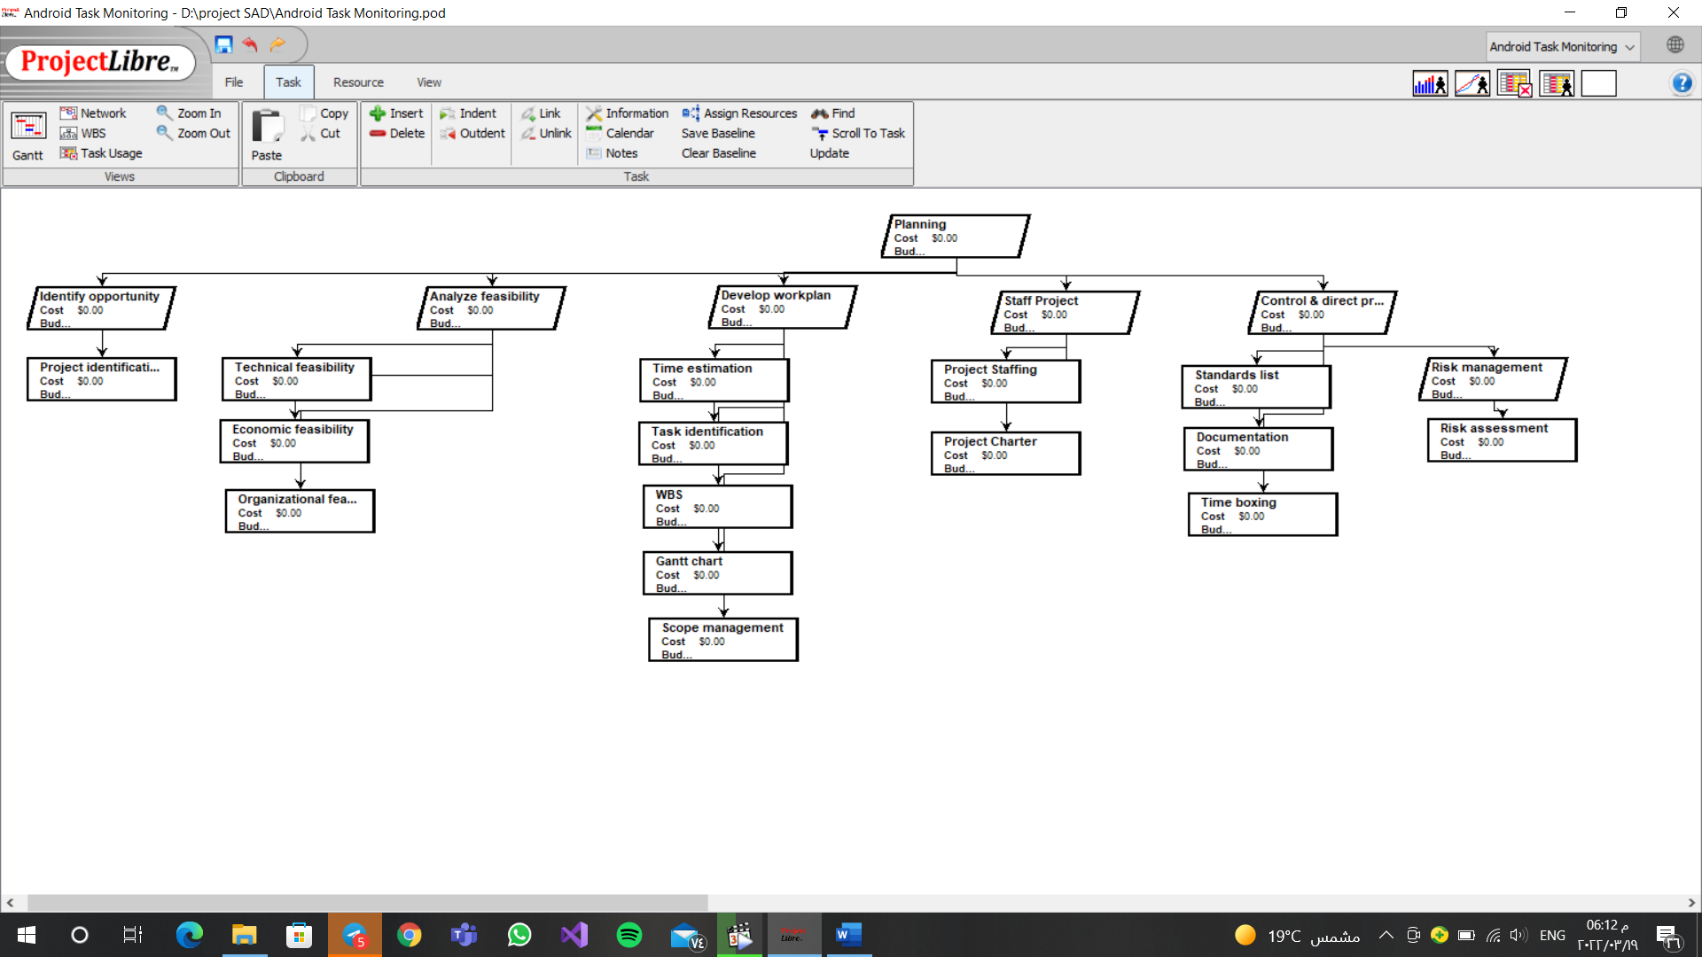

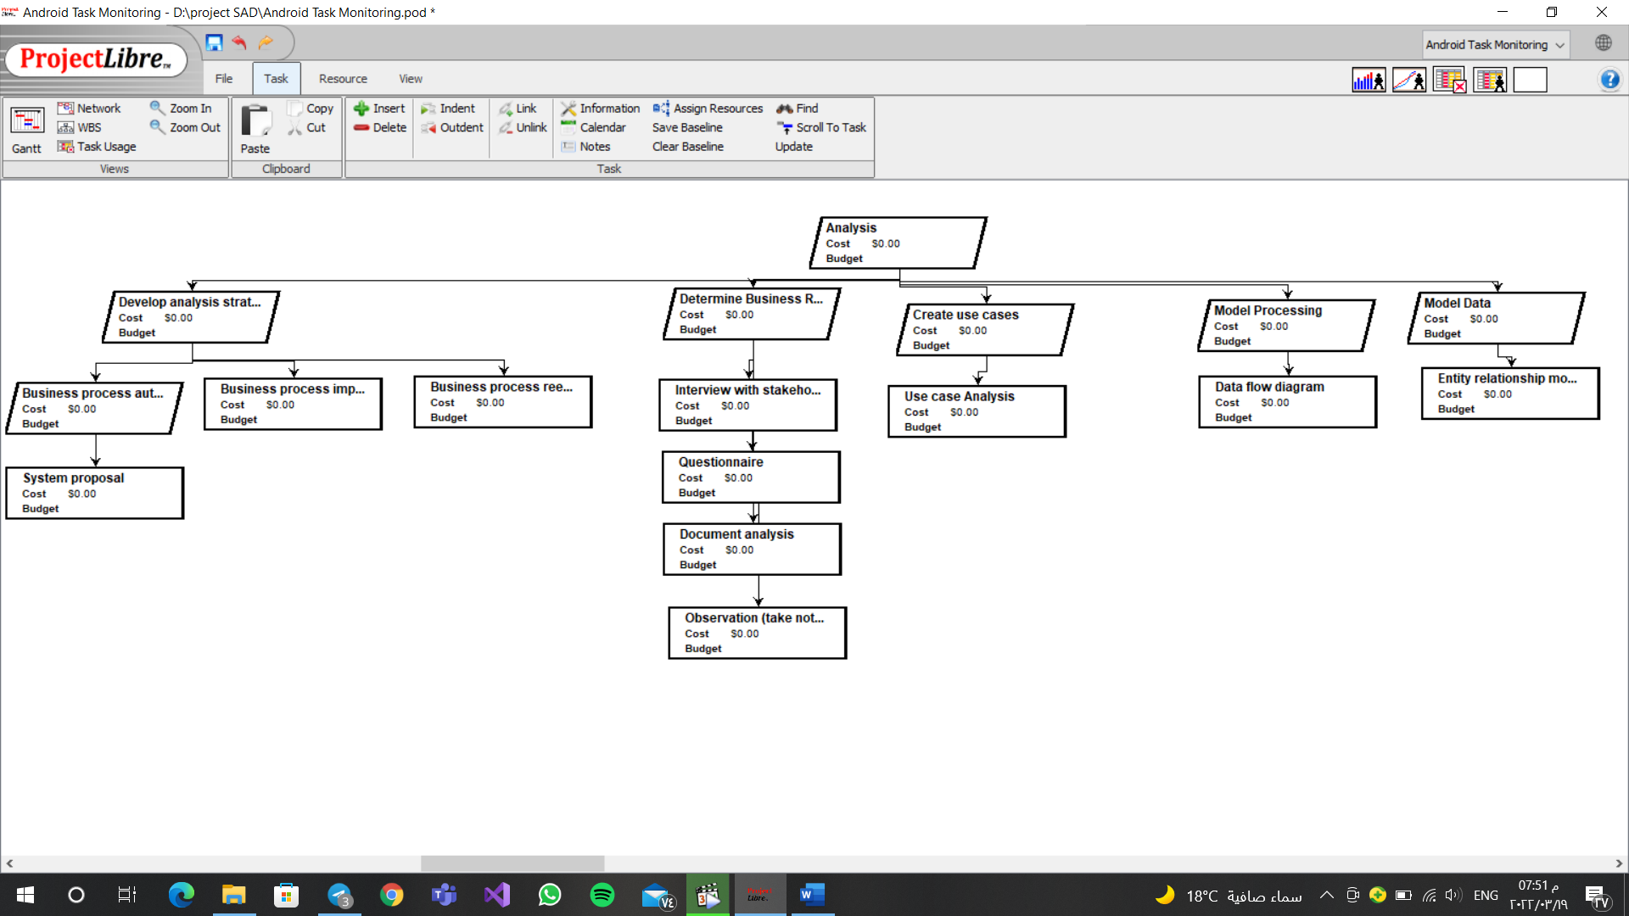

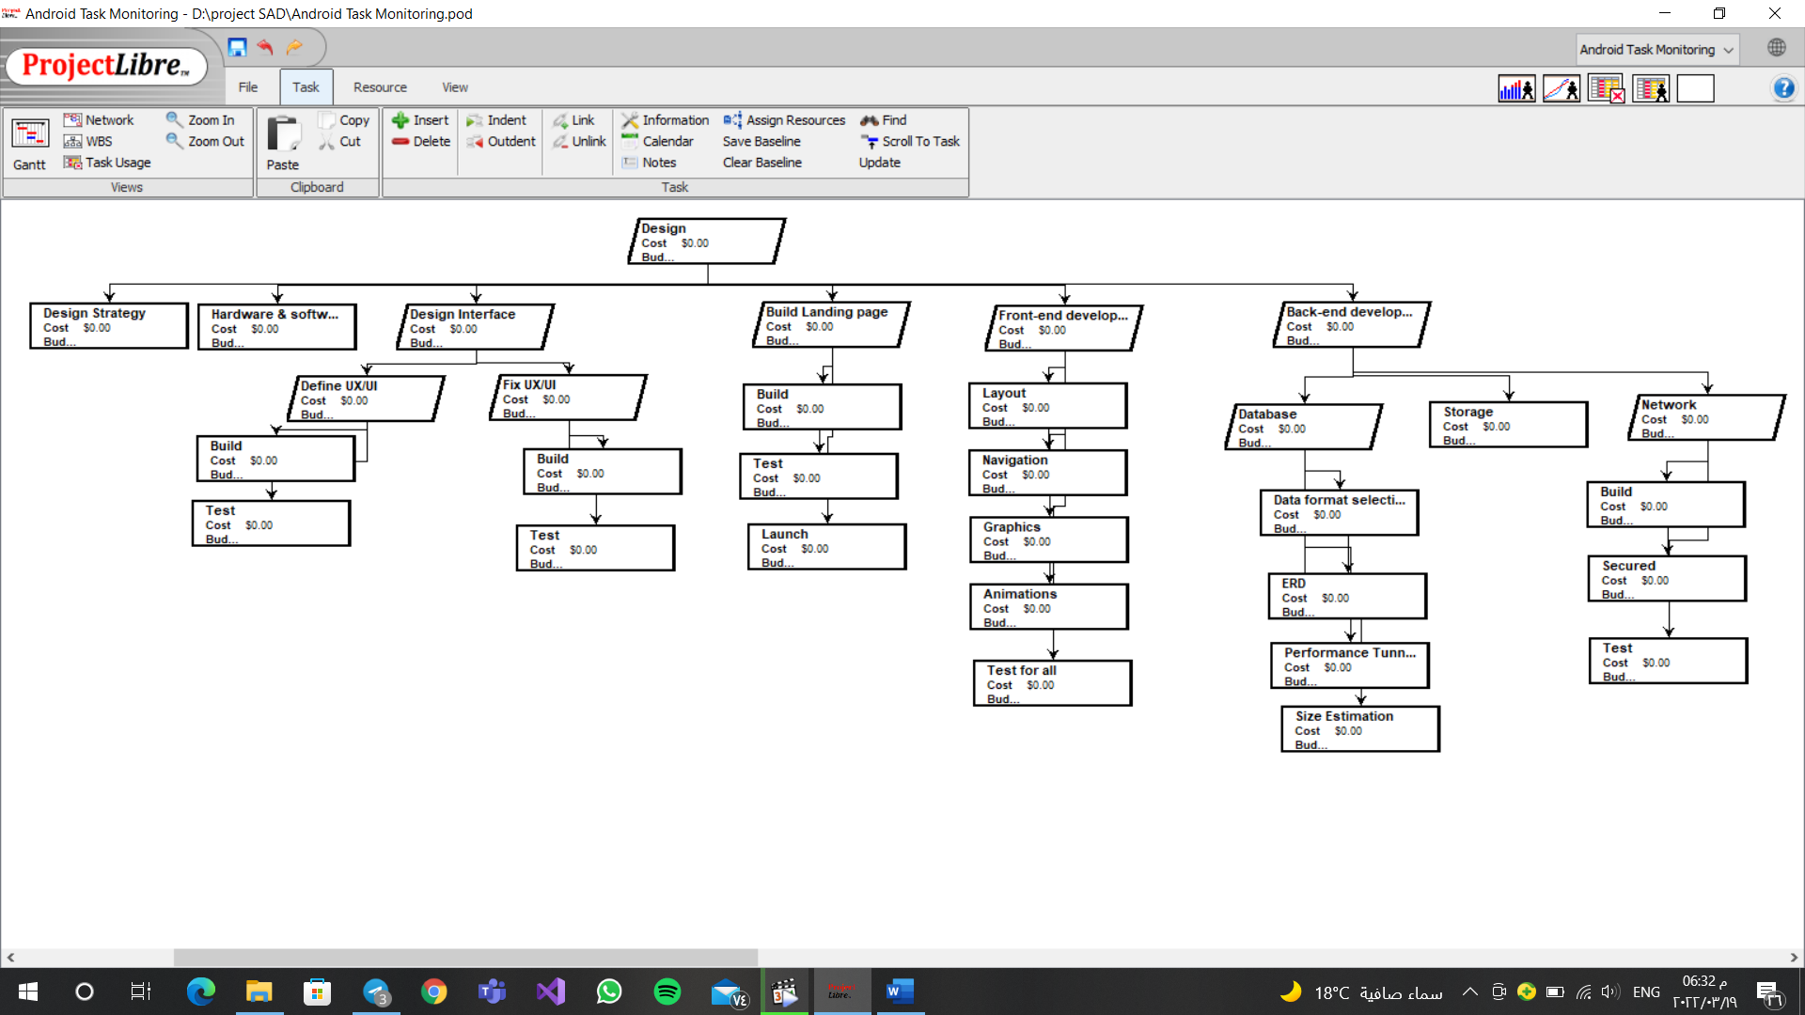

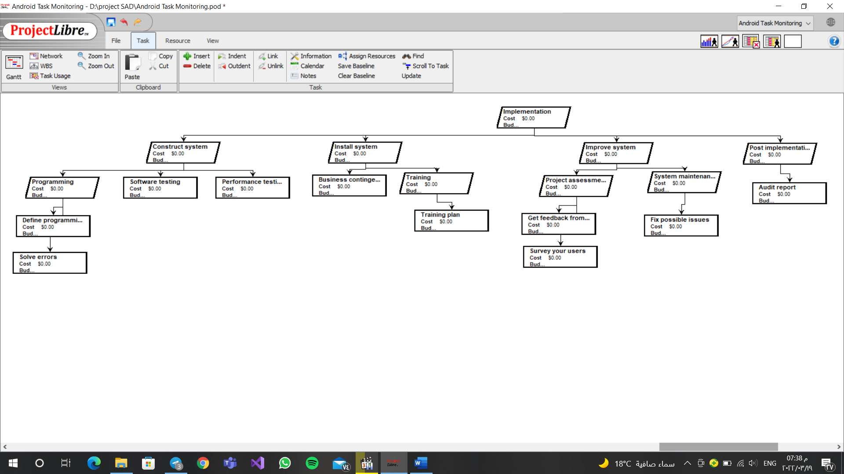

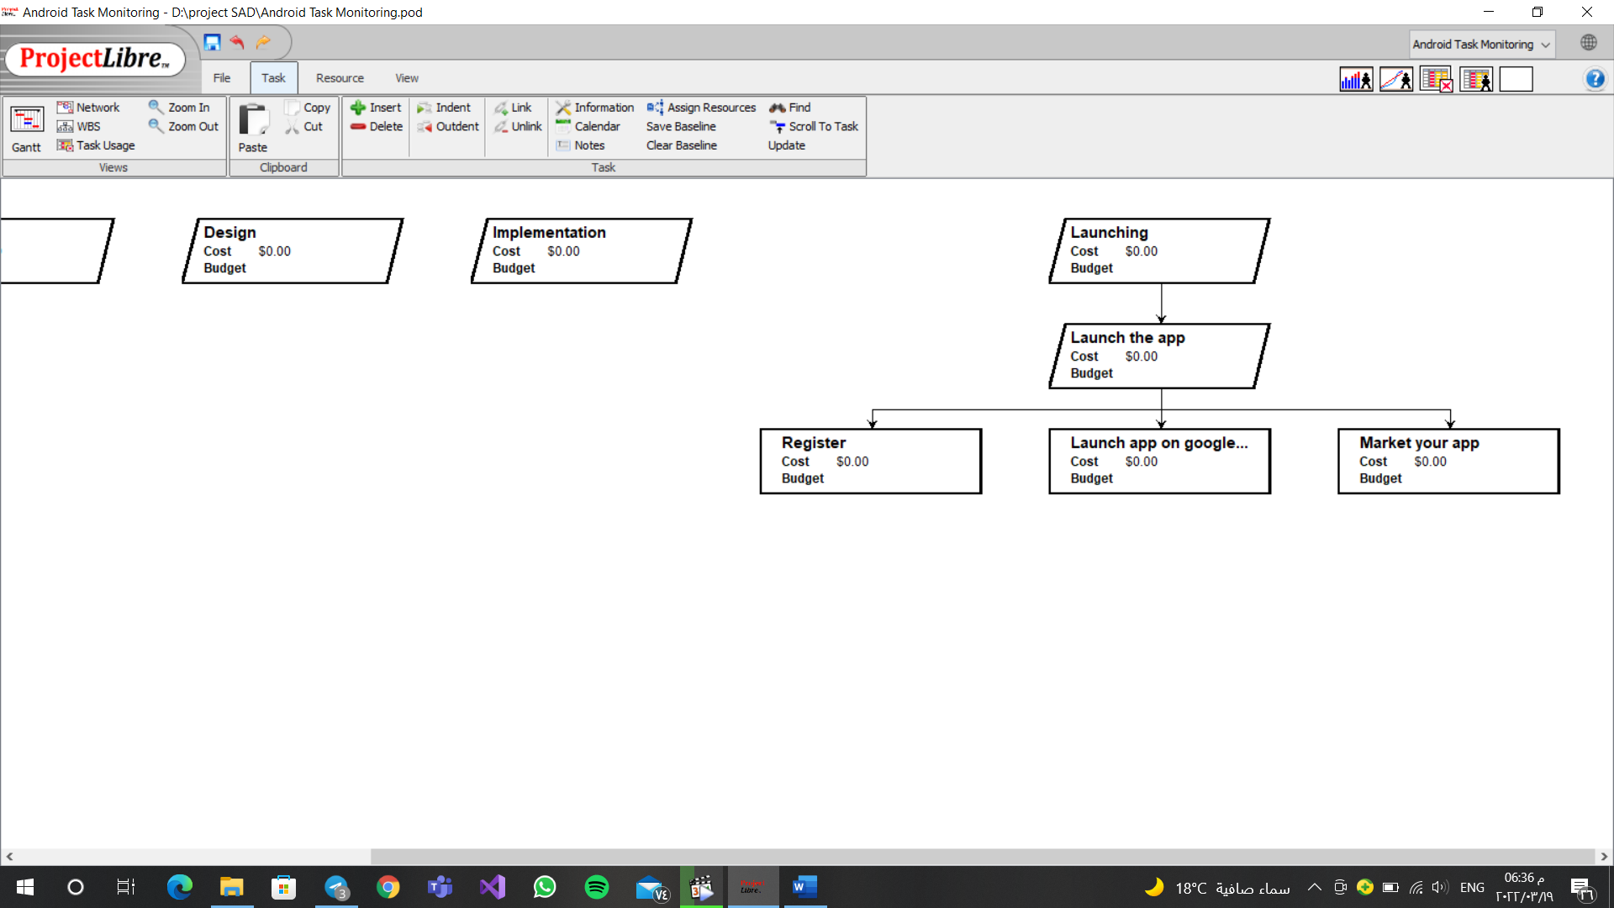

|  |  |  |  |  |  |  |  |  |  |  |
| --- | --- | --- | --- | --- | --- | --- | --- | --- | --- | --- |
| Task id | Task name | Assigned to | Estimated | | | Actual | | | Dependency | Status |
| Duration (days) | Start date | Finish date | Start date | Finish date | Duration variance |
| 1 | **Planning** |  | 60 | 1/1 | 3/3 |  |  |  |  | Open |
| 1.1 | Identify opportunity | Maria | 3 | 1/1 | 4/1 | 1/1 | 4/1 | 0 |  | Complete |
| 1.1.1 | Project identification | Maria | 3 | 1/1 | 4/1 | 1/1 | 4/1 | 0 |  | Complete |
| 1.2 | Analyze feasibility |  | 5 | 5/1 | 9/1 | 5/1 | 9/1 | 0 | 1.1 | Complete |
| 1.2.1 | Technical feasibility | Mary Clara | 1 | 5/1 | 6/1 | 5/1 | 6/1 | 0 | 1.1.1 | Complete |
| 1.2.2 | Economic feasibility | Marian Kirollos | 3 | 6/1 | 9/1 | 6/1 | 9/1 | 0 |  | Complete |
| 1.2.3 | Organizational feasibility | Mary-Clara | 1 | 5/1 | 6/1 | 5/1 | 6/1 | 0 |  | Complete |
| 1.3 | Develop workplan |  | 15 | 10/1 | 25/1 | 10/1 | 25/1 | 0 | 1.2 / 1.1 | Complete |
| 1.3.1 | Time estimation | Maria | 5 | 10/1 | 15/1 | 10/1 | 15/1 | 0 | 1.2.1 | Complete |
| 1.3.2 | Task identification | Clara | 2 | 15/1 | 17/1 | 15/1 | 17/1 | 0 |  | Complete |
| 1.3.3 | WBS | Maria  Clara  Mary  Marian | 3 | 17/1 | 20/1 | 17/1 | 20/1 | 0 | 1.3.2 | Complete |
| 1.3.4 | Gantt chart | Maria | 1 | 20/1 | 21/1 | 20/1 | 21/1 | 0 | 1.3.1/1.3.3 | Complete |
| 1.3.5 | Scope management | Kirollos | 4 | 21/1 | 25/1 | 21/1 | 25/1 | 0 | 1.1 / 1.2 / 1.3.1 | Complete |
| 1.4 | Staff project |  | 15 | 25/1 | 9/2 |  |  |  |  | Open |
| 1.4.1 | Project staffing(Staffing plan) | Clara | 10 | 25/1 | 4/2 |  |  |  | 1.3.2 / 1.3.4 | Open |
| 1.4.2 | Project charter | Marian | 5 | 4/2 | 9/2 |  |  |  | 1.3.5 / 1.3.4 | Open |
| 1.5 | Control & direct project |  | 22 | 9/2 | 3/3 |  |  |  |  | Open |
| 1.5.1 | Standards list | Mary | 7 | 9/2 | 16/2 |  |  |  | 1.3.5 | Open |
| 1.5.2 | Documentation | Kirollos | 5 | 16/2 | 21/2 |  |  |  | 1.1 / 1.2 /1.3/ 1.4 | Open |
| 1.5.3 | Time boxing | Maria | 4 | 21/2 | 25/2 |  |  |  | 1.3.1 | Open |
| 1.5.4 | Risk management | Marian | 6 | 25/2 | 3/3 |  |  |  |  | Open |
| 1.5.4.1 | Risk assessment | Marian | 6 | 25/2 | 3/3 |  |  |  | 1.4.2 | Open |
| 2 | **Analysis** |  | 120 | 4/3 | 2/7 |  |  |  | 1 | Open |
| 2.1 | Develop analysis strategy |  | 45 | 4/3 | 18/4 |  |  |  |  | Open |
| 2.1.1 | Business process automation | Maria | 10 | 4/3 | 14/3 |  |  |  |  | Open |
| 2.1.1.1 | System proposal | Maria | 10 | 4/3 | 14/3 |  |  |  |  | Open |
| 2.1.2 | Business process improvement | Mary | 20 | 14/3 | 3/4 |  |  |  |  | Open |
| 2.1.3 | Business process reengineering | Marian | 15 | 3/4 | 18/4 |  |  |  |  | Open |
| 2.2 | Determine Business Requirements |  | 40 | 18/4 | 28/5 |  |  |  | 2.1 | Open |
| 2.2.1 | Interview with stakeholders | Clara | 10 | 18/4 | 28/4 |  |  |  |  | Open |
| 2.2.2 | Questionnaire | Kirollos | 10 | 28/4 | 8/5 |  |  |  | 2.2.1 | Open |
| 2.2.3 | Document analysis | Maria | 10 | 8/5 | 18/5 |  |  |  | 2.2.1/2.2.2 | Open |
| 2.2.4 | Observation (take notes) | Marian | 10 | 18/5 | 28/5 |  |  |  | 2.2.3 | Open |
| 2.3 | Create use cases | Mary  Kirollos | 10 | 28/5 | 7/6 |  |  |  |  | Open |
| 2.3.1 | Use case Analysis | Mary  Kirillos | 10 | 28/5 | 7/6 |  |  |  | 2.1/2.2 | Open |
| 2.4 | Model Processing | Marian | 15 | 7/6 | 22/6 |  |  |  |  | Open |
| 2.4.1 | Data flow diagram | Marian | 15 | 7/6 | 22/6 |  |  |  | 2.1/2.2/2.3 | Open |
| 2.5 | Model Data | Clara | 10 | 22/6 | 2/7 |  |  |  |  | Open |
| 2.5.1 | Entity relationship modeling | Clara | 10 | 22/6 | 2/7 |  |  |  | 2.4 | Open |
| 3 | **Design** |  | 90 | 2/7 | 2/10 |  |  |  | 1 /2 | Open |
| 3.1 | Design Strategy | Clara  Mary  Kirollos | 10 | 2/7 | 12/7 |  |  |  |  | Open |
| 3.2 | Hardware & software selection | Maria  Marian | 5 | 12/7 | 17/7 |  |  |  | 3.1 | Open |
| 3.3 | Design Interface |  | 7 | 17/7 | 24/7 |  |  |  | 3.1 / 3.2 | Open |
| 3.3.1 | Define UX/UI |  | 4 | 17/7 | 21/7 |  |  |  |  | Open |
| 3.3.1.1 | Build | Marian | 3 | 17/7 | 20/7 |  |  |  | 3.3.1/ 3.1 | Open |
| 3.3.1.2 | Test | Kirollos | 1 | 20/7 | 21/7 |  |  |  | 3.3.1.1 | Open |
| 3.3.2 | Fix UX/UI |  | 3 | 21/7 | 24/7 |  |  |  | 3.3.1/3.1 | Open |
| 3.3.2.1 | Build | Maria | 2 | 21/7 | 23/7 |  |  |  | 3.3.2 | Open |
| 3.3.2.2 | Test | Clara | 1 | 23/7 | 24/7 |  |  |  | 3.3.2.1 | Open |
| 3.4 | Build Landing page |  | 8 | 24/7 | 1/8 |  |  |  | 3.1 | Open |
| 3.4.1 | Build | Mary | 4 | 24/7 | 28/7 |  |  |  |  | Open |
| 3.4.2 | Test | Maria | 2 | 28/7 | 30/7 |  |  |  | 3.4.1 | Open |
| 3.4.3 | Launch | Clara | 2 | 30/7 | 1/8 |  |  |  | 3.4.2 | Open |
| 3.5 | Front-end development |  | 30 | 1/8 | 31/8 |  |  |  | 3.1 | Open |
| 3.5.1 | Layout | Clara | 6 | 1/8 | 7/8 |  |  |  |  | Open |
| 3.5.2 | Navigation | Mary | 6 | 7/8 | 13/8 |  |  |  |  | Open |
| 3.5.3 | Graphics | Marian | 6 | 13/8 | 19/8 |  |  |  |  | Open |
| 3.5.4 | Animations | Maria | 6 | 19/8 | 25/8 |  |  |  |  | Open |
| 3.5.5 | Test for all | Kirollos | 6 | 25/8 | 31/8 |  |  |  | 3.5.1/3.5.2/3.5.3/  3.5.4 | Open |
| 3.6 | Back-end development |  | 30 | 31/8 | 1/10 |  |  |  | 3.1 | Open |
| 3.6.1 | Database |  | 20 | 31/8 | 20/9 |  |  |  |  | Open |
| 3.6.1.1 | Data format selection | Maria | 4 | 31/8 | 4/9 |  |  |  |  | Open |
| 3.6.1.2 | ERD | Clara | 9 | 4/9 | 13/9 |  |  |  | 3.6.1.1 | Open |
| 3.6.1.3 | Performance Tunning | Kirollos | 4 | 13/9 | 17/9 |  |  |  | 3.6.1.1/3.6.1.2 | Open |
| 3.6.1.4 | Size Estimation | Mary | 3 | 17/9 | 20/9 |  |  |  | 3.6.1.1 | Open |
| 3.6.2 | Storage | Marian | 4 | 20/9 | 24/9 |  |  |  | 3.1/3.6.1 | Open |
| 3.6.3 | Network |  | 6 | 24/9 | 30/9 |  |  |  | 3.1 | Open |
| 3.6.3.1 | Build | Marian | 3 | 24/9 | 27/9 |  |  |  |  | Open |
| 3.6.3.2 | Secured | Clara | 2 | 27/9 | 29/9 |  |  |  | 3.6.3.1 | Open |
| 3.6.3.3 | Test | Mary | 1 | 29/9 | 30/9 |  |  |  | 3.6.3.2 | Open |
| 4 | **Implementation** |  | 60 | 30/9 | 29/11 |  |  |  | 1/2/3 | Open |
| 4.1 | Construct system |  | 20 | 30/9 | 20/10 |  |  |  |  | Open |
| 4.1.1 | Programming |  | 10 | 30/9 | 10/10 |  |  |  |  | Open |
| 4.1.1.1 | Define programming languages | Marian | 5 | 30/9 | 5/10 |  |  |  | 3.2 | Open |
| 4.1.1.2 | Solve errors | Maria | 5 | 5/10 | 10/10 |  |  |  |  | Open |
| 4.1.2 | Software testing | Kirollos | 5 | 10/10 | 15/10 |  |  |  | 4.1.1 | Open |
| 4.1.3 | Performance testing | Mary | 5 | 15/10 | 20/10 |  |  |  | 4.1.1/4.1.2 | Open |
| 4.2 | Install system |  | 15 | 20/10 | 4/11 |  |  |  | 4.1 | Open |
| 4.2.1 | Business contingency plan | Clara | 5 | 20/10 | 25/10 |  |  |  |  | Open |
| 4.2.2 | Training | Kirollos | 10 | 25/10 | 4/11 |  |  |  |  | Open |
| 4.2.2.1 | Training plan | Kirollos | 10 | 25/10 | 4/11 |  |  |  | 4.2.1 | Open |
| 4.3 | Improve system |  | 20 | 4/11 | 24/11 |  |  |  | 4.1/4.2 | Open |
| 4.3.1 | Project assessment |  | 10 | 4/11 | 14/11 |  |  |  |  | Open |
| 4.3.1.1 | Get feedback from user | Marian | 5 | 4/11 | 9/11 |  |  |  |  | Open |
| 4.3.1.2 | Survey your users | Mary | 5 | 9/11 | 14/11 |  |  |  |  | Open |
| 4.3.2 | System maintenance | Maria | 10 | 14/11 | 24/11 |  |  |  |  | Open |
| 4.3.2.1 | Fix possible issues | Maria | 10 | 14/11 | 24/11 |  |  |  | 4.3.1 | Open |
| 4.4 | Post implementation | Clara | 5 | 24/11 | 29/11 |  |  |  |  | Open |
| 4.4.1 | Audit report | Clara | 5 | 24/11 | 29/11 |  |  |  | 4.1/4.2/4.3 | Open |
| 5 | **Launching** |  | 30 | 29/11 | 29/12 |  |  |  | 1/2/3/4 | Open |
| 5.1 | Launch the app |  | 30 | 29/11 | 29/12 |  |  |  |  | Open |
| 5.1.1 | Register |  | 10 | 29/11 | 9/12 |  |  |  |  | Open |
| 5.1.2 | Launch app on google play | Kerollos | 5 | 9/12 | 14/12 |  |  |  |  | Open |
| 5.1.3 | Market your app | Clara  Mary  Marian  Maria | 15 | 14/12 | 29/12 |  |  |  |  | Open |

Interview Summary

|  |  |  |  |
| --- | --- | --- | --- |
| Name | Position | Purpose | Meeting |
| Mohammed Shahin | Performance data analyst | - Understand previous experience with similar apps.  - Collect information about (to-be system) | Fri, March 25  12:45 – 1:00 (pm) |
| Abadeer Saber | Manager of Petra company | - Understand previous experience with similar apps.  - Collect information about (to-be system) | Fri, March 25  3:00-3:15 (pm) |
| Waheed Gamil | T.A | - Understand previous experience with similar apps.  - Collect information about (to-be system) | Fri, March 25  5:00-5:15 (pm) |
| Mohammed Salah | T.A | - Understand previous experience with similar apps.  - Collect information about (to-be system) | Fri, March 25  9:00-9:30 (pm) |
| Ahmed Elhawary | Gym coach | - Understand previous experience with similar apps.  - Collect information about (to-be system) | Fri, March 25  10:00-10:15 (pm) |
| Shady Saber | English teacher | - Understand previous experience with similar apps.  - Collect information about (to-be system) | Sat, March 26  9:00-9:30 (am) |
| Dr.Ehab Samir | ENT (Otolaryngologists) | - Understand previous experience with similar apps.  - Collect information about (to-be system) | Sat, March 26  2:00-2:30 (pm) |
| Mariam Melad | Medical representative | - Understand previous experience with similar apps.  - Collect information about (to-be system) | Sat, March 26  7:00-7:15 (pm) |
| Students | Different colleges | - Understand previous experience with similar apps.  - Collect information about (to-be system) | Fri, March 25 to Sat, March 26 |

|  |
| --- |
| Interview Notes Approved by: Mohammed Shahin |
| Person Interviewed: Mohammed Shahin, Performance data analyst, Swvl  Interviewer: Marian Ashraf  Purpose of interview:   * Understand previous experience in dealing with similar applications. (As-is system) * Determine information requirements for the future system. (To-be system)   Summary of interview:   * Mr. Mohammed suggested to make the user customize Pomodoro technique, like: 50 mins studying and 10 mins break or 25 mins studying and 5 mins break.   Open Item:   * None   Detailed Notes:   * Are you interested in this category of applications?   Yes.   * Have you ever tried this category of applications?   No   * What are features would you like to exist in the application?   The time of study is 50 minutes studying and 10 minutes break or make it  an option for the user to choose the desired period.   * How do you find this application useful in your practical life?   Not very useful, but it is based on the nature of the work.  For example, at my work, we do meetings suddenly, so I have to delay all  the other things that have been set for me.   * On your point of view, what are the disadvantages that would make you stop using this application?   Nothing. |

|  |
| --- |
| **Interview Notes Approved by: Abader Saber** |
| **Person Interviewed**: Abader Saber , Manager of Petra company  **Interviewer:** Clara Bassem / Kerollos George  **Purpose of interview:**   * Understand previous experience in dealing with similar applications. (As-is system) * Determine information requirements for the future system. (To-be system)   **Summary of interview:**   * Mr. Abadeer recommended: * That the app recommends for you any courses on Coursera and Udemy   commensurate with each one interests.   * Link different person’s applications accounts with our app. * Automatically recognizing for appointments from messages and chats. * Focus mode.   **Open Item:**   * None   **Detailed Notes:**   * **Are you interested in this category of applications?**   Yes, sure   * **Have you ever tried this category of applications?**   Yes, Huawei notepad   * **What are features would you like to exist in the application?** * That the app recommends for you any courses on Udemy and   Coursera commensurate with each one interests.   * Link different person’s applications accounts with our app. * Automatically recognizing for appointments from messages and chats. * Focus mode(digital balance which specified some time on each application) * **How do you find this application useful in your practical life?**   It will help me managing meetings, deadlines, and tasks.   * **On your point of view, what are the disadvantages that would make you stop using this application?** * Not flexible * Slow ــ Not accurate. |

|  |
| --- |
| Interview Notes Approved by: Eng : Waheed Gamil |
| Person Interviewed: Eng: Waheed Gamil,  teaching assistant at faculty of computer & information system.    Interviewer: Mary Gergis / Maria Ayman.  Purpose of interview:   * Understand previous experience in dealing with similar applications. (As-is system). * Determine information requirements for the future system. (To-be system).   Summary of interview:   * Mr Waheed recommended to add: * Enspiring messages as a feature in our app. * Make the app suggests the user possible solutions for current task (if I have done this task before).   Open Item:   * None.   Detailed Notes:   * Are you interested in this category of applications?   Yes.   * Have you ever tried this category of applications?   No.   * What are features would you like to exist in the application? * Feature that show me feedback after doing task. * Feature that send me notification if I started doing task but not finished it yet to tell me to finish it. * Suggest me possible solutions for current task (if I have done this task before) send me notifications to tell me that I did this task before. * Send me notification to alert me with important dates & meetings. * Show me inspiring quotes. * How do you find this application useful in your practical life? * It will be useful for me in my work. * On your point of view, what are the disadvantages that would make you stop using this application?   Nothing. |

|  |
| --- |
| Interview Notes Approved by: Eng : Mohammed Salah |
| Person Interviewed: Eng: Mohammed Salah,  teaching assistant at faculty of computer & information system.    Interviewer: Mary Gergis.  Purpose of interview:   * Understand previous experience in dealing with similar applications. (As-is system). * Determine information requirements for the future system. (To-be system).   Summary of interview:   * Mr. Mohammed recommended: * The focus mood and mute notifications from another apps. * There is separate section for daily routine tasks. * Enable the user to send & receive important mails. * Alert us for better interface design.   Open Item:   * None.   Detailed Notes:   * Are you interested in this category of applications?   Yes.   * Have you ever tried this category of applications?   Yes.   * What is the name of application that you used?   Microsoft to do.   * What are features would you like to exist in the application? * Mute all social media notifications not to get distracted while working and this feature will be special of other similar applications. * There is separate section for daily routine tasks. * Send me notification to alert me with important dates & meetings. * Enable me to send & receive important mails. * Alert me with alarm notification by ringtone.      * How do you find this application useful in your practical life? * It will be useful for me to manage time and remind me with important tasks.      * It will help me to avoid much wasted time on social media and therefore it will save time for useful tasks. * On your point of view, what are the disadvantages that would make you stop using this application?   Nothing.   * Do you have any additional comments ? * Design of application will make it attractive for more users and will make it special from any similar applications. * This application will be very useful , will make better for people lives , save wasted time and manage it. |

|  |
| --- |
| **Interview Notes Approved by: Ahmed Yasser El Hawary** |
| **Person Interviewed:** Ahmed Yasser El Hawary , Fitness Trainer  **Interviewer:** Clara Bassem  **Purpose of interview:**   * Understand previous experience in dealing with similar applications. (As-is system) * Determine information requirements for the future system. (To-be system)   **Summary of interview:**   * Mr. Ahmed was very busy to handle his appointments and needs this app to manage his time with his clients. * The app will suggest nutrition and functional training courses to help him with his work. * We noted that fitness trainers in badly need for time management applications.   **Open Item:**   * None.   **Detailed Notes:**   * **Are you interested in this category of applications?**   Yes.   * **Have you ever tried this category of applications?**   No.   * **What are features would you like to exist in the application?**   All I want something help me manage my different appointments because I’m get confused and missing some important meetings.   * **How do you find this application useful in your practical life?**   It is so useful for me because I’m a so busy.   * **On your point of view, what are the disadvantages that would make you stop using this application?**   Nothing will make me stop using application like this one. |

|  |
| --- |
| **Interview Notes Approved by: Shady Saber** |
| **Person Interviewed:** Shady Saber, English teacher and business man.  **Interviewer:** Clara Bassem  **Purpose of interview:**   * Understand previous experience in dealing with similar applications. (As-is system) * Determine information requirements for the future system. (To-be system)   **Summary of interview:**   * Mr. Shady sees that the personal life is as important as career life so we need to balance between them with using time management apps.   **Open Item:**   * None   **Detailed Notes:**   * **Are you interested in this category of applications?**   Yes, I’m interested of any way that is used in time management.   * **Have you ever tried this category of applications?**   No, But I use notebook and paper planners.   * **What are features would you like to exist in the application?**   I don’t have specific features in my mind but I want it to help me in my work  by making it easy to schedule my lessons and my business meetings.   * **How do you find this application useful in your practical life?**   I think it will help me to make balance between my personal life and my career life.   * **On your point of view, what are the disadvantages that would make you stop using this application?**   If it was difficult to use. |

|  |
| --- |
| Interview Notes Approved by: Dr.Ehab Samir |
| Person Interviewed: Dr. Ehab Samir, ENT (Otolaryngologists)  Interviewer: Kerollos George.  Purpose of interview:   * Understand previous experience in dealing with similar applications. (As-is system) * Determine information requirements for the future system. (To-be system)   Summary of interview:   * Dr. Ehab recommended to make many categories of lists to differ between his tasks.   Open Item:   * None   Detailed Notes:   * Are you interested in this category of applications?   No.   * Why?   Because I used an application before and there were many problems in it.   * What were the problems with it? * Lags * Crashes * It was using big space comparable with its performance. * It didn’t have a lot of features; it was very simple. * If you found an application that can solve all of these problems, would you use it?   Yes.   * What are the additional features would you like to exist in the application? * Many categories of lists. (Medical – Personnel – etc...) * The interface is attractive. * The balance between practical and personnel life. * Send notifications to remind me of the deals with the medical rep. * How do you find this application useful in your practical life? * Remind me with reservations. * Remind me of important meetings. * Do you have any additional comments?   No, thank you. |

|  |
| --- |
| **Interview Notes Approved by: Mariam Melad** |
| **Person Interviewed:** Mariam Melad , Medical representative  **Interviewer:** Clara Bassem  **Purpose of interview:**   * Understand previous experience in dealing with similar applications. (As-is system) * Determine information requirements for the future system. (To-be system)   **Summary of interview:**   * Mrs. Mariam recommended: * There is separate section for daily routine tasks. * Alert us for encourage messages.   **Open Item:**   * None   **Detailed Notes:**   * **Are you interested in this category of applications?**   Yes.   * **Have you ever tried this category of applications?**   No, only use mobile note.   * **What are features would you like to exist in the application?** * Remind me of my doctor visits * Remind me of Supervisor meetings * Remind me of pharmacies orders * Schedule my daily work plan * Encouraging messages * **How do you find this application useful in your practical life?**   It makes my work easier and help me saving some time to do different activities.   * **On your point of view, what are the disadvantages that would make you stop using this application?**   Nothing. |

|  |
| --- |
| Interview Notes Approved by: Students |
| Person Interviewed: students from different colleges.  Interviewer: Mary Gergis / Maria Ayman / Kerollos George/Marian Ashraf/Clara Bassem  Purpose of interview:   * Understand previous experience in dealing with similar applications. (As-is system). * Determine information requirements for the future system. (To-be system).   Summary of interview:   * Students recommended: * Track and send notification to tell me time spent using each app. * Make each task with different color & design not to get me distracted. * Make a sleep schedule to help me sleeping. * The app is for free. * Take notes during the meetings. * Share focus time with friends to be like a challenge. * Points after you finish a certain task (collecting points to buy new themes). * Title & subtitle list. * Consuming less data usage. * Not recommended: * When application go wrong , don’t run correctly and don’t alert me for tasks on exact time. * Big storage * Boring interface   Open Item:   * None   Detailed Notes:   * Are you interested in this category of applications?   Yes.   * Have you ever tried this category of applications?   Yes   * What is the name of application that you used?   Do simple to do list / To do list / Any.do / Microsoft to do   * What are features would you like to exist in the application? * Track and send notification to tell me time spent using each app. * Alert me by notification ringtone. * Make application easy and more simple. * Show me inspiring quotes. * Make each task with different color & design not to get me distracted. * Make a sleep schedule to help me sleeping. * The app is for free. * Take notes during the meetings. * Share focus time with friends to be like a challenge. * Points after you finish a certain task (collecting points to buy new themes). * Title & subtitle list. * Consuming less data usage. * Enables application to send me notification before each task by 1 hour and send me another notification on the exact time. * Enables application to delete task after it has been finished. * How do you find this application useful in your practical life?   It enables me to manage my tasks accurately.   * On your point of view, what are the disadvantages that would make you stop using this application? * A lot of advertisements as it will make me bored. * A lot of alarms for unimportant tasks for me. * When application go wrong, don’t run correctly and don’t alert me for tasks on exact time. * Big storage * Boring interface |

|  |
| --- |
| Functional requirements |
| Achievements management   * Monitoring day-to-day activities * Set goals and achieve them * Reminder by notifications and AI assistant * Available templets for user * Priorities * Sleep schedule * Title & subtitle * Task & subtask * Link different personal accounts with our app * Automatically recognize appointments from chats * Make the app suggests to the user the possible solutions for the current task (If I have done this task before) * Motivational messages   Studying   * Study stream * Pomodoro technique * Share my focus time with friends to be a challenge * Mute all social media notifications * Make the user customize the Pomodoro technique * Our app recommends for you any courses from your interests from Coursera & Udemy   Teams   * Take notes during meetings (AI assistant) * Link a group of people with each other (Group) and make them available to put appointments they have together   Entertainment   * Rewards after tasks (Coins to buy a new theme) * Listen to music   Technical   * Secured accounts * Fast & consuming less data (Internet) usage * Use less Space * Avoid Crashes * Attractive interface * Make each task with different colors & designs to not get distracted |
| Nonfunctional requirements |
| Operational   * The system will run on Android mobile devices. * The system should be able to integrate with the existing inventory system. * The app will use 95 MB from the storage of the mobile phone.   Performance   * Any interaction between the user and the system should not exceed 2 seconds. * The system should be available for use 24 hours per day, 365 days per year. * The system supports 150,000 simultaneous users at all times.   Security   * Data in the database is encrypted. * Technicians& developers can see only their work assignments. * Data inside the application, register information, and PayPal accounts are encrypted. * The system includes all available antivirus programs and safeguards from viruses, worms, Trojan horses, etc. * Only direct managers can see staff personnel records.   Culture and Political   * The system should be able to distinguish between US currency and currency from other nations. * Software license validity. * Take a license to make the user able to install the app. * Company policy is to buy computers only from Lenovo. * Personal information is protected in compliance with the Data Protection Act. * Make a contract with PayPal. * Make a contract with Oracle (for database). |

Use Cases

|  |  |  |  |
| --- | --- | --- | --- |
| Priority: High | ID: UC-1 | Use case name: Purchase the program | |
| Actor: The user | | | |
| Description: purchasing(buying) the android task monitoring from play store before download it,  Because it’s a paid application. | | | |
| Trigger: When the user click on(Buy bottom) for our application on play store.  Type: External | | | |
| Preconditions:  (1) Having a bank account.  (2) Having a visa card.  (3) Having Google play account. | | | |
| Information for Steps:  🡸app name  🡺message of app’s cost  🡸the user’s approval | **Normal Course:**  (1) The user open play store then search for our app  (2) Click buy  (3) The system send him message (50$) for downloading.  (4) The user agree for this message (alternative course 1).  (5) Have enough money in the visa for downloading.  (6) Purchasing process is done. | | |
| 🡺warning message. | **Alternative Courses:**  (Branch from step 4)  1- if The money in visa isn’t enough for downloading.  2-The system will send a message for the user “Money isn’t enough, use another visa”. | | |
| Post conditions:  (1) program is already downloaded.  (2) System will not take any other fees. | | | |
| Exceptions:  (Branch form step 4)  1-Visa is invalid  2-The system send to the user “ Visa is invalid” | | | |
| Destination | **Outputs** | **Source** | **Summary Inputs** |
| User  User | 1- message of app’s cost  2-Warning message | User  User | 1-App name.  2-The user’s approval. |

|  |  |  |  |
| --- | --- | --- | --- |
| Priority: High | ID: UC-2 | Use case name: Register | |
| Actor: The user | | | |
| Description: The user regists in our app and make an account. | | | |
| Trigger: When the user sign in or sign up.  Type: External | | | |
| Preconditions:  (1)The user already downloaded the app  (2) The mobile should be connected to the internet | | | |
| Information for Steps:  🡺Welcome message  🡸The user approves for creating an account  🡺Personal form  🡸 User personal information. | **Normal Course:**  (1)The system will send welcome message to the user.  (2)The User chooses sign up (alternative course)  (3)The user press on create an account  (4)The system shows the register personal form.  (5)The user fills the form  (6)The user clicks on “create” | | |
| 🡸User account | **Alternative Courses:**  (Branch from step 2)  1-the user sign up with Facebook account or Google account.  2-The account is created. | | |
| Post conditions:  1-Account is created  2-The user should full the list. | | | |
| Exceptions:  (Branch from step 2)  1-ther user click sign in without having an account.  2-System sends him a message “this account isn’t exist sign up or exit”. | | | |
| Destination | **Outputs** | **Source** | **Summary Inputs** |
| User  User | 1-Personal message.  2-Personal form. | User  User  User | 1-The user approves for creating an account.  2- User personal information.  3-User account. |

|  |  |  |  |
| --- | --- | --- | --- |
| Priority: High | ID: UC-3 | Use case name: Title & subtitle | |
| Actor: The system and the user. | | | |
| Description:  -System displays main title and subtitle lists to the user.  -The user wants to add new title and subtitle list and write his tasks. | | | |
| Trigger: When the user opens the app after creating an account, see the main title and subtitle lists that has already exist in the app and adding a new tittle or subtitle list if he wants.  Type :External | | | |
| Preconditions:  1) The user has an account.  2) The mobile should be connected to the internet.  3) Open (share location mood) | | | |
| Information for Steps:  🡺title and subtitle lists  🡸the user desired list  🡺subtitle lists of studying  🡺 sub-lists of study stream  🡺chats sub-lists  🡺 ready streams  🡸desired stream  🡺 ready streams  🡸desired stream  🡺 meetings sub-lists  🡺current and create new buttons  🡺current and create new buttons  🡺 the sub-lists of “Me”  🡺Default and customize buttons  🡺Time and applications buttons  🡺 the sub-lists of teams  🡺 the sub-lists of achievements | **Normal Course:**  1)When user open the app, the system displays main titles and subtitles list( Studying ,teams, achievements)  2)when the user click on his desired title list**(Alter.1)**  **2a- If the user clicks on “Studying”**  -The system will display the sub-lists(Study stream ,Me )  **2.a.1-**The user clicks on “Study stream”  - The system will display the sub-lists of study stream(Chats,  Meetings)  **2.a.1.1 -if he chooses chats**  -the system will display chats sub-lists(universal, local, linked  Accounts.  **2.a.1.1.1-if the user chooses universal**  -the system will displays ready streams  -the user chooses desired stream  **2.a.1.1.2-if the user chooses local**  -the system will displays ready streams  -the user chooses desired stream  **2.a.1.1.3-if the user chooses linked accounts**  **2.a.1.2 -if he chooses meetings**  -the system will display meetings sub-lists(universal ,local, linked accounts)  **2.a.1.2.1-if the user chooses universal**  -System displays two bottoms(current , create new)  **2.a.1.2.2-if the user chooses local**  -System displays two bottoms(current , create new)  **2.a.1.2.3-if the user chooses linked accounts**  -System displays two bottoms(current , create new)  **2.a.2-**The user clicks on “Me”  - The system will display the sub-lists of “Me”(recommended  Courses , Pomodoro button , focus button)  **2.a.2.1 -if he chooses** **recommended courses**  **2.a.2.2 -if he chooses pomodoro button**  -The system will displays two buttons(Default, Customize)  **2.a.2.3 -if he chooses Focus button**  -The system will displays two Lists (time ,applications)  **2b- If the user clicks on “Teams”**  -The system will display the sub-lists of teams (Take notes during meetings (AI assistant**,** Link a group of people with each other (Group) and make them available to put appointments they have together  **2c-If the user chooses “Achievements list”**  -The system will display the sub-lists(Daily, weekly, monthly)  Look the next use case(US-4) | | |
| 🡸customized list  🡺 Save the new title list | **Alternative Courses:**  **Branch from step 2**  1)If the user wants to create new title list  2) the user presses on ”other” button.  3)Then creates his customize title list  4) press save button. | | |
| Post conditions:  1)The user created his title and subtitle lists  2)The use set reminder for his tasks. | | | |
| Exceptions:  The user has a maximum of 3 options to add title lists by himself on the app, so the option "Other…" won't be enabled to use.  1. If the user already added 3 new title lists on the app and wants to add again it won't work and a list will be shown to the user telling him *"You have used the maximum number of adding new title-lists on the app. delete one of them if you want to add another title-list or use the Application’s"*  a . If he chooses "*delete*" the system will show the new 3 title-lists that the user added and delete one of them.  b. if he pressed *“use the Application”* the system will open the “home page” | | | |
| Destination | **Outputs** | **Source** | **Summary Inputs** |
| User  User  User  User  User  User  User  User  User  User  User  User  Database | 1)title and subtitle lists  2) subtitle lists of studying  3) sub-lists of study stream  4)chats sub-lists  5) ready streams  6) meetings sub-lists  7) current and create new bottoms  8) the sub-lists of “Me”  9) Normal and customizebottoms  10)Time and applications bottoms  11) the sub-lists of teams  12)the sub-lists of achievements  13) Save the new title list | User  User  User | 1) the user desired list  2) desired stream  3) customized list |

|  |  |  |  |
| --- | --- | --- | --- |
| Priority: High | ID: UC-4 | Use case name: Achievements | |
| Actor: User | | | |
| Description: In this use case the user see how to deal with one of the main lists which is(achievements list)and its inner subtitles lists, know how to add a new task in subtitle list or adding another subtitle list. | | | |
| Trigger: The user wants to add a task to the achievements list  Type: External | | | |
| Preconditions:  The user must have an account and already signed in. | | | |
| Information for Steps:    🡺Main Lists  🡸the user choose    🡺Sub-lists of daily list  🡸 the user choose Subtitles  🡸 new task button  🡸data of tasks    🡺message of reminder  🡸user’s reminder approval  🡺time schedule from system  🡺 Sub-lists of weekly list  🡸 the user choose Subtitles  🡸 new task button  🡸data of tasks  🡺message of reminder  🡸user’s reminder approval  🡺time schedule from system  🡺 Sub-lists of yearly list  🡸 the user choose Subtitles  🡸 new task button  🡸data of tasks  🡺message of reminder  🡸user’s reminder approval  🡺time schedule from system | **Normal Course:**  1- The user opens the achievements list.  2-The system displays the main subtitles of achievements list(daily ,weekly ,monthly)(Alter.1)  3- The user chooses the desired subtitle.  **3a-If the user chooses daily**  -The system displays the subtitles (Tasks, Dairy, Shopping, Sports time, Break time, or Medicine)  -The user chooses the desired subtitle to add the task in **(Alter. 1)**  - press on the button *new task* to add a new one.  - After completing the writing, the user should then press on *"save* *button"* to save the task.  -Then the system asks the user if he wants to set a reminder or not  -The user wants to add a reminder  -The system gives him a time schedule to set the time that he will be reminded.  - then press *"OK"* to set the time.  - then the system returns the user to the *"Achievements List "*.  **3b-If the user chooses weekly**  -The system displays the subtitles (Tasks, Shopping, Meetings, or Therapeutic sessions)  -The user chooses the desired subtitle to add the task in. **(Alter. 1)**  - press on the button *new task* to add a new one.  - After completing the writing, the user should then press on *"save* *button"* to save the task.  -The system asks the user if he wants to set a reminder or not  -The user wants to set a reminder  -The system gives him a time schedule to set the time that he will be reminded.  - then press *"OK"* to set the time.  - then the system returns the user to the *"Achievements List"*.  **3c-If the user chooses monthly**  -The system displays the subtitles (Tasks, Shopping, Meetings, Therapeutic sessions, or Fees)  -The user chooses the desired subtitle to add the task in **(Alter. 1)**  - press on button *"new task"* to add a new one.  - After completing the writing, the user should then press on *"save* *button"* to save the task.  -The system asks the user if he wants to set a reminder or not  -The user wants to add a reminder  -The system gives him a time schedule to set the time that he will be reminded.  - then press *"OK"* to set the time.  - then the system returns the user to the *"Achievements List"*.  -The user chooses other (Alter. 1). | | |
| 🡸 Other button  🡸 the user choose Subtitles and title  🡸 data of tasks  🡺message of reminder  🡸user’s reminder approval  🡺time schedule from system | **Alternative Courses:**  **-Branch from step 2,step 3a,b,c(for adding another sub-list and a new task in it)**  1. The user chooses other button.  2. The user adds the desired title and subtitles he wants.  3. press on button *"new task"* to add a new one.  4. After completing the writing, the user should then press on *"save* *button"* to save the task.  5. The system asks the user if he wants to set a reminder or not  6. The user wants to add a reminder  7. The system gives him a time schedule to set the time that he will be reminded.  8. then press *"OK"* to set the time. | | |
| Postconditions:  1. The tasks have been assigned.  2. The reminders have been set. | | | |
| Exceptions:  The user has a maximum of 3 options to add lists by himself on the same list, so the option "Others…" won't be enabled to use.  1. If the user already added 3 new lists on the same list and wants to add again it won't work and a list will be shown to the user telling him *"You have used the maximum number of adding new sub-lists on the same list… delete one of them if you want to add another sub-list or use the Application"*  A . If he chooses "*delete*" the system will show the new 3 sub-lists that the user added and delete one of them.  b. if he pressed *"use the Application"* the system will open the "home page" | | | |
| Destination | **Outputs** | **Source** | **Summary Inputs** |
| User  User  User  User  User  User | 1) Main Lists  2) Sub-lists of daily list  3) message of reminder  4) time schedule from system  5) Sub-lists of weekly list  6) Sub-lists of yearly list | User  User  User  User  User  System  User  User | 1)the user choose  2) the user choose Subtitles  3) new task button  4)data of tasks  5) user’s reminderapproval  6)Other button  7)the user choose Subtitles and title  8)data of tasks |

|  |  |  |  |
| --- | --- | --- | --- |
| Priority: High | ID: UC-5 | Use case name: Reminder | |
| Actor: AI system | | | |
| Description: the process where the AI system will remind the user to do the tasks that haven’t been done yet. | | | |
| Trigger: When user sets reminder for his tasks then it’s the time to remind, AI system acts like the following steps.  Type: Temporary | | | |
| Preconditions:  -The user already sets his Title and subtitle list | | | |
| Information for Steps:  🡺reminder message  🡸the user did the task  🡺encouraging message  🡺Market coins go to warehouse of the program | **Normal Course:**  1)AI assistant system sends a reminder message when the time of the task comes  2)If the user click on “Done” bottom(Alter.1)  - System will send an encourage message to the user.  - The user will get coins to buy themes from market. | | |
| 🡸 the user delays the task  🡺time schedule  🡸user selects time | **Alternative Courses:**  1)The user click on ”Remind me later”  -The AI system will appear a schedule contains time (hours, minutes, seconds)  -The user selects time which he would like the system to remind him. | | |
| Postconditions:  -The user’s coins will increase so he can buy new themes.  - Encourage messages will increase the user’s productivity. | | | |
| Exceptions:  3)When user cancels the task  - AI system will remove the task from list. | | | |
| Destination | **Outputs** | **Source** | **Summary Inputs** |
| User  User  Warehouse  User | 1) Reminder message  2)Encouraging message  3) Market coins go to warehouse of the program  4)Time schedule | User  User  User | 1) The user did the task  2) The user delays the task  3)User selects time |

|  |  |  |  |
| --- | --- | --- | --- |
| Priority: High | ID: UC-6 | Use case name: Focus time | |
| Actor: The user | | | |
| Description: the user wants to specific some applications to close them & their notifications not to interrupt and can focus easily on his/her task. | | | |
| Trigger: the user wants to focus on his/her tasks and not to interrupt him/her so the system will close specific apps.  Type*: Temporal External* | | | |
| Preconditions:  1 – The user must have an account and signed in already.  2 – The user has important something that need to be focused on. | | | |
| Information for Steps:  Choosing study list  Displaying study list  Choosing Me list  Displaying Me list  Choosing focus time  Display time List  Displaying applications List Confirm process  Focus lock | **Normal Course:**  1 – The user opens the app.  2 – The user chooses study list from titles & subtitles.  3- The system displays the sub-lists of study list (Me – Study stream).  3 – the user chooses "Me list".  4- The system displays (Pomodoro Button – Recommended Courses – Focus time Button).  4 – The user presses on "Focus time" button.  5 – The system displays:  a. Default time List which is (for 5 hours). (Alter. 1)  b. Default Applications List (Facebook – Twitter – Instagram – TikTok - YouTube). (Alter. 2)  6 – the user presses confirm button.  7- the system closes default applications with default time. | | |
| Customized time  Customized applications | **Alternative Courses:**  1 – if user wants to add customized time, press "Customized" in time list then the system displays time schedule with hours and minutes then user adds time he wants. (Branch at step 5a)  2- If user wants to choose customized Applications, press "Customized" in Applications list then the system displays Applications List (all apps the phone has). | | |
| Postconditions:  1 – The customized apps will be closed during the customized time.  2 – The user won't receive any notification from these apps. | | | |
| Exceptions:  1 – The user needed to cancel the focus time during doing the task. | | | |
| Destination | **Outputs** | **Source** | **Summary Inputs** |
| The user  The user  The user  The user  The system of Android | 1. Displaying study list  2. Displaying Me list  3. Displaying time List  4. Displaying applications List  5. Focus lock | The user  The user  The user  The user  The user  The user | 1. Choosing study list  2. Choosing Me list  3. Choosing focus time  4. Confirm process  5. Customized time  6. customized applications |

|  |  |  |  |
| --- | --- | --- | --- |
| Priority: High | ID: UC-7 | Use case name: Market | |
| Actor: the user | | | |
| Description: the user wants to buy new themes from the market by collected coins | | | |
| Trigger: the user needs to buy new themes to use them  Type: Temporal External | | | |
| Preconditions:  1 - the tasks have been done on the exact time.  2 - The mobile must be connected to the internet.  3 - the user must have coins to enable him to buy new themes. | | | |
| Information for Steps:  List of themes  Choose specific themes  Confirmation buying | **Normal Course:**  1- the user goes to the cart button.  2 - the app opens list to show available themes.  3 - press the desired theme that the user wants to buy.  4 - if coins are enough to buy the desired theme, it will be added to home page and available to be used. (Alternative i)  5 - app will show to the user the remaining coins of his account and will show message that ***“your shopping has been done successfully and the desired theme is added to your account ... hope to enjoy using our app!”*** | | |
| Ask whether to buy another theme  List of remaining themes  Choosing theme    Confirmation shopping    Press No  Cancel message  Cancellation | **Alternative Courses:**  (i):  1 - if coins are not enough to buy specific theme. (branch at step 4)  2 - the system show message to user ***"Do you want to buy another theme with enough coins?"***  2a - the user answers ***"yes"*** then system shows available themes again with their prices.  3a - the user chooses another theme with suitable coins he/she has in his/her cart.  4a - the user confirms his/her shopping.  5a - new theme will be added to home page of user`s account and ready to be used.  2b - the user answers ***"No"***.  3b - the system shows message ***" Do you want to cancel your shopping now! "***.  4b - if the user approved to cancel his/her shopping, the system terminates the use case. | | |
| Postconditions:  1 – the new theme will be added to the user’s account.  2 – the coins of user’s account will be decreased after buying new themes. | | | |
| Exceptions:  1 – the system has zero coins or account is still new and not used before.  2- the system will cancel shopping of the user. | | | |
| Destination | **Outputs** | **Source** | **Summary Inputs** |
| The user  The system  The user  The user  The user | 1- List of themes  2 - Confirmation buying  3- Ask whether to buy another theme  4 – List of remaining themes.  5 - Cancel message | the user  the user  the user  the user  the user | 1 – Choose specific themes.  2 –Choosing theme.    3 – Confirmation shopping.  4 - Press No  5 - Cancellation |

|  |  |  |  |
| --- | --- | --- | --- |
| Priority: High | ID: UC-8 | Use case name: Logout | |
| Actor: the user | | | |
| Description: the user wants to logout from his/her account | | | |
| Trigger: the user wants to logout from his/her account  Type: External Temporal | | | |
| Preconditions:  1 - the user must have an account of app.  2- the user has already signed in the account.  3- the mobile must be connected the internet. | | | |
| Information for Steps:  Logout  Warning message  Approved to logout | **Normal Course:**  1 - the user presses the button ***"logout".***  2 - the system shows message ***"Are you sure to logout* from this app*?"***  3 - if the user press ***"yes"***.  4 - the system will logout the account. | | |
| Disapproved logout  Cancellation logout | **Alternative Courses:**  1 - The user presses ***"NO".*** (Branch at step 2).  2 **-** the system won’t logout and continue in the application usage. | | |
| Postconditions:  1 - the system will logout from the account.  2 - the sign in window will be shown again to re-login in the app. | | | |
| Exceptions:  1 - Mobile isn’t connected to the internet, the system won’t logout and continue in the application usage. | | | |
| Destination | **Outputs** | **Source** | **Summary Inputs** |
| The user  The system | 1 – Warning message  2 – cancellation logout | The user  The user  The user | 1 – Logout  2 – Approved to logout  3 – Disapproved to logout |

